Submitted to

Submitted by

Bokaro Industrial Area

September 2021

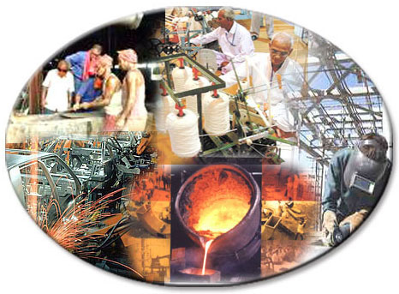

Certificate of originality
Original work of TERI done under the project “Facilitating Green Economic Recovery: Improving the uptake of cleaner technologies among MSMEs in Eastern India”

This document may be reproduced in whole or in part and in any form for educational and non-profits purposes without special permission, provided acknowledgement of the source is made. SSEF and TERI would appreciate receiving a copy of any publication that uses this document as a source.

Suggested format for citation
TERI. 2021
Bokaro Industrial Area
New Delhi: The Energy and Resources Institute.
[Project Report No. 2020IE14]

Disclaimer
This document is an output of a research exercise undertaken by TERI supported by The Shakti Sustainable Energy Foundation (SSEF) for the benefit of MSME sector. While every effort has been made to avoid any mistakes or omissions, TERI and SSEF would not be in any way liable to any persons/organisations by reason of any mistake/ omission in the publication.

Published by
TERI Press
The Energy and Resources Institute
Darbari Seth Block
IHC Complex, Lodhi Road
New Delhi-110 003
India

For more information
Project Monitoring Cell
T E R I Tel. 2468 2100 or 2468 2111
Darbari Seth Block E-mail pmc@teri.res.in
IHC Complex, Lodhi Road Fax 2468 2144 or 2468 2145
New Delhi – 110 003 Web www.teriin.org
India India +91 • Delhi (0)11

Contents

Acknowledgements 1
Jharkhand Overview 2
Bokaro Industrial Area 2
Overview of Industrial Area 2
Products, market and production capacities 2
Technologies employed 3
Energy scenario 4
Energy consumption 5
Potential energy efficient technologies 5
Major Industrial Area Development activities 9
About TERI 10
About SSEF 10

Acknowledgements
TERI places on record its sincere thanks to The Shakti Sustainable Energy Foundation (SSEF) for supporting the project on Facilitating Green Economy among MSMEs in Eastern India.

TERI extends its sincere thanks to Ms. Keerthishree G (IAS), Regional Director, Jharkhand Industrial Area Development Authority and Mr P. Rajesh, Secretary, Uddyamshakti for providing support and information related to industries for field visits during the study for the preparation of this cluster profile report.

Last but not least, our sincere thanks to all MSME entrepreneurs and other key stakeholders in the industrial area for providing valuable data and inputs that helped in analysis.

TERI

Jharkhand Overview
Jharkhand state is rich in minerals and well occupied to the flora and fauna in the region. The Jharkhand Industrial Policy-2001, formulated by the Jharkhand State Industry Association aims at enhancing value addition of natural and human resources in efficient manner and generating additional employment and resources. As many as 26 mega industries, 106 large and medium industries and 18,109 micro and small industries were set up in Jharkhand with an overall investment of INR 28,000 crore. Further 63,000 people were provided employment in these industries. It helped in improving the quality of life in areas like Jamshedpur-Saraikela-Chaibassa, Ramgarh-Patratu-Hazaribagh, Latehar-Chandwa, Ranchi-Lohardaga, Bokaro-Chandankiyari-Dhanbad-Giridih etc. The state at present has three Industrial Development Authorities with headquarters at Adityapur, Bokaro and Ranchi.

Based on discussions with various stakeholders such as governmental bodies, industrial associations, and district industry centres, Bokaro Industrial Area was short-listed for undertaking activities pertaining to “cleaner technologies and green economy project”.

Bokaro Industrial Area

Overview of Industrial Area
Bokaro, the Steel City of India, is one of the major industrial hubs in Jharkhand. One of the major public sector company is ‘Bokaro steel plant’ with an annual steel production of 4 million tonne (mt). The Bokaro Industrial Area consists of four phases; Phase-1 & Phase-2 are over 50 years old, comprising more than 200 industries that include ancillary industries for Bokaro Steel Plant along with many fabrication and flour mills. Phase-3 & Phase-4 are newly developed areas since 2010 and consists of more than 150 industries. The Bokaro industrial area consists of many steel ancillary fabrications and engineering works small scale industries along with few flour mills..

Category | Number of units
Fabrication & engineering works | 135
Foundry | 10
Food industries (Flour mills) | 5
Total | 150

Products, market and production capacities
The foundry units produce castings and iron bars for component manufacturing. The steel fabrication units produce industrial machinery and accessories parts. Products like blast furnace rollers, economiser parts, pressure vessels and conveyor systems and heavy engineering parts. The flour mills produce wheat flour, channa sattu (roasted channa) and organic spices.

The major raw material for foundry units is different iron grades scrap and mild steel (MS) sheets, rods and bars. The fabrication and engineering units use sheet metal for fabrication of variety of parts for industries within and outside the state. Major products are manufactured by machine tools include conventional lathe machine, press machine, drilling machine, bending machine, rolling machine, boring machine, special purpose machine and welding machine along with finishing tools like grinders and material handling tools.

Technologies employed
Some of the major processes/equipment used in manufacturing units are described below.

(i) Conventional machining
The units use conventional machines for the fabrication and manufacturing of various components. Conventional machining includes power driven machine tools such as lathes, milling, rolling, bending, shearing, grinding and drilling machines.
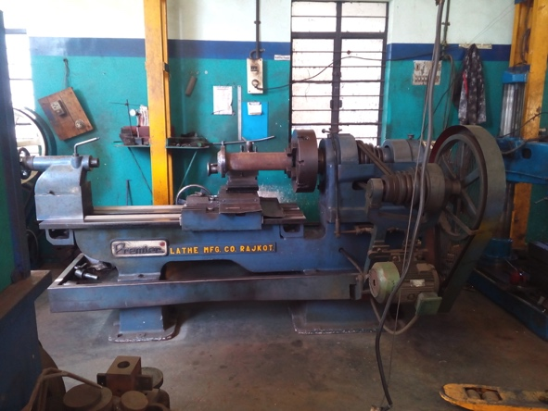
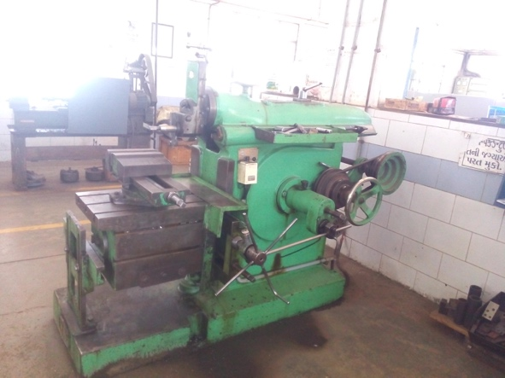
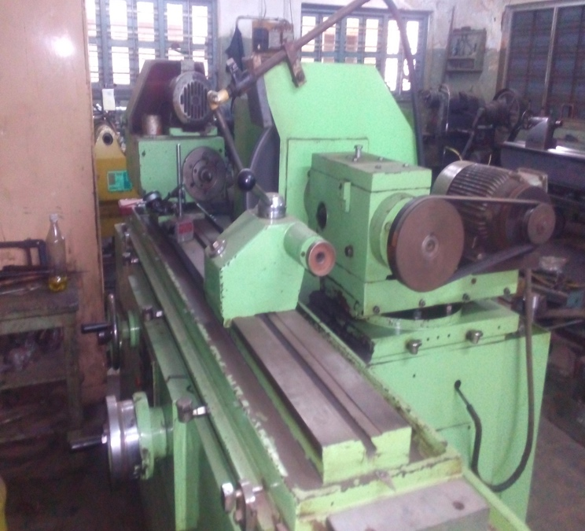
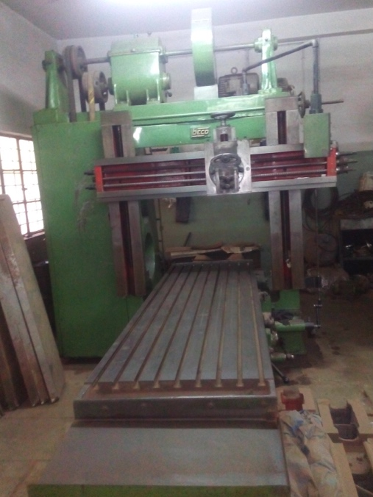
Lathe machine
Milling machine
Cylindrical grinding machine
Shaping machine

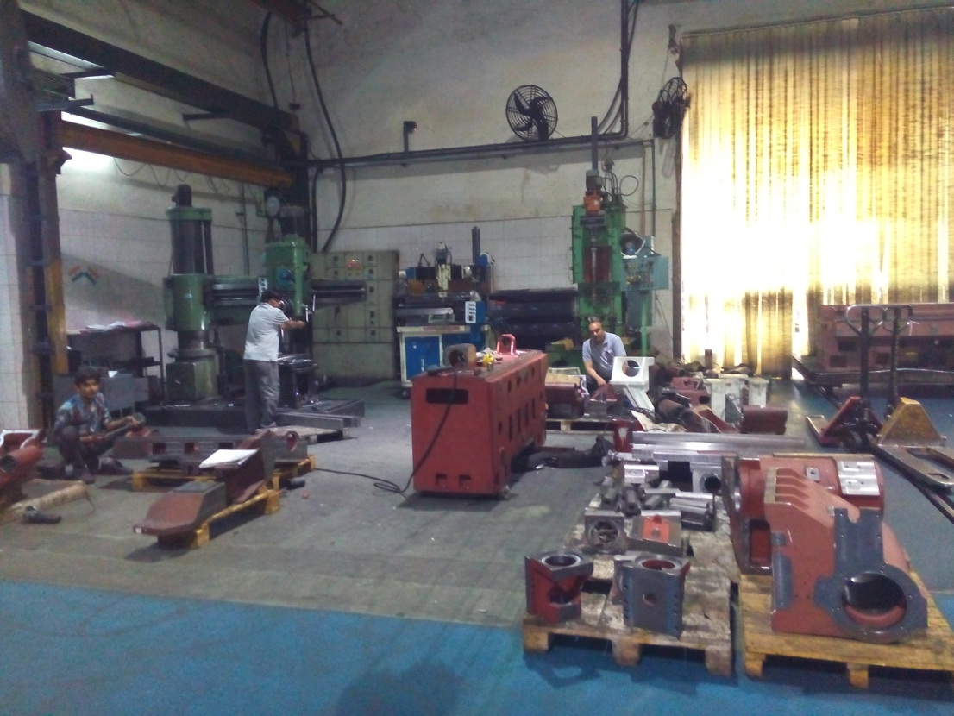
(ii) Manual assembling
Manual assembly area
Most of the units in the industrial area follow manual assembling process. Assembly work is modified depending on machine and customization requirements. Major fabrication units work under the same process of assembly of small components.

(iv) Air compressor
Compressed air is used in various pneumatic applications, cleaning purpose, painting etc. The pressure requirement for the majority of applications is below 7 kg/cm².The connected load of compressed air system may vary from a few kW (single air compressor) for a small/ micro scale unit to 22 kW for a medium scale manufacturing unit.

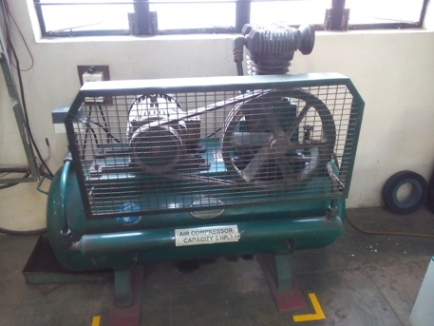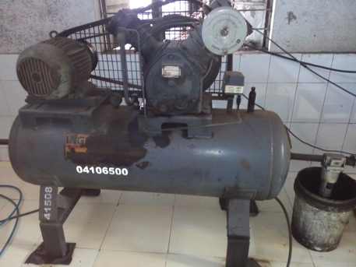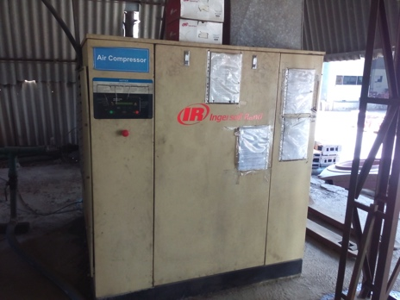
Screw air compressor
Reciprocating air compressors

Energy scenario
Electricity is the main source of energy used in all the units in the Bokaro Industrial Area. Electricity is supplied through Jharkhand Bijli Vitran Nigam Limited (JBVNL) / Damodar Valley Corporation (DVC). Diesel is used in DG sets to generate electricity to meet requirements during power outage. Generally, there is a power outage of about 2 to 4 hours per day in Bokaro Industrial Area. The increase in diesel prices and long hours power outage, high diesel consumption lead to increased energy cost share in overall production.

Prices of major energy sources
Source | Remarks | Price
Electricity | High Tension connection (HT) | Rs 7.5 per kWh (inclusive of energy, demand charges, other penalty/rebate and electricity duty)
 | Low Tension connection (LT) | Rs 7.0 per kWh (inclusive of energy, demand charges and electricity duty)
Diesel | Local market | Rs 90 per litre (In the month of August 2021)

Energy consumption

(i) Unit level consumption
Electricity is the main energy source. Most of the units have HT connections with exceptions of micro scale industries like fabrication and steel enterprises. The power supplied at 11 kV is stepped down to 433 V and fed to respective power distribution board (PDB) through LT switchgear located at main distribution.

The major energy consuming areas are electric furnaces, motors used in various applications, air compressors, SPMs, lathe, rolling, welding, boring, cranes, etc. which are operated for longer durations. Electrical motors account for about 85% of total energy consumption followed by welding machines (8%) and compressed air system (5%). There is no-uniformity in running of machines, as most of them operate when particular operation has to be performed.

Potential energy efficient technologies
Some of the major energy efficient technologies relevant for the industrial area are discussed below.
- Energy Efficient IE3 standard motors
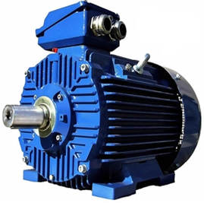
The units in the industrial area are using lathe machines, hydraulic press machines, drilling machines, boring, bending machines etc. which use electrical motors. The ratings of these motors vary from 0.5 HP to 50 HP depending on the capacity of machine and operations to be performed. Most of these motors operate on low loads. The power factor of these motors was observed to be generally lower than 0.85.
IE3 motor

Due to presence of significant variable and jerk loading pattern observed in motors used in machines, rewinding of motors is carried out at specific intervals. There is a lack of awareness about efficiency standards of motors. It was observed that most of the units use low efficiency standard motors. There is a significant potential for energy savings by replacing low efficiency motors with energy efficient IE3 standard motors. Depending on the operation period of the machines, payback period for EE motors can vary between 5 to 7 years depending on the period of operation. Energy saving of 2% can be achieved on replacement of old IE2 motor with IE3 motor and savings upto 7% can be achieved on replacement of old IE1 standard motor with IE3 motor.

Cost benefit analysis for IE3 motors
Parameter | Unit | 10 HP motor | 15 HP motor
Power consumption of existing motor | kW/hr | 7.6 | 12.2
Efficiency of existing motor | % | 88.1 | 89.4
Efficiency of IE3 standard motor | % | 90.1 | 91.4
Estimated power consumption of IE3 motor | kW/hr | 7.4 | 11.9
Annual energy cost savings @3000 hrs/yr | Rs /yr | 3,300 | 4,950
Investment required | Rs | 17,250 | 34,500
Simple Payback Period | Yr | 5.2 | 7.0

- Air compressor
Compressed air is used in various pneumatic applications, cleaning purpose, painting, etc. Power rating of these compressors ranges from 5 HP to 30 HP. Larger units use screw compressors whereas smaller units use reciprocating compressors. Screw compressors are designed to operate on more than 80% load for efficient performance. There is a huge potential for energy saving by adopting ‘variable frequency drives’ (VFD) based screw air compressors and Permanent Magnet Motor (PMM) based air compressors having higher free air discharge to power ratio. Energy savings can range from 15 to 40% compared with the existing system.
Cost benefit of VFD for screw air compressor
Parameter | Unit | Value
Loading | % | 35
Unloading | % | 65
Annual energy cost savings | Rs | 1,05,600
Investment required for VFD | Rs | 2,00,000
Simple payback period | Yr | 1.9

- Installing metal cutter and retrofitting swing lid mechanism in furnace crucible
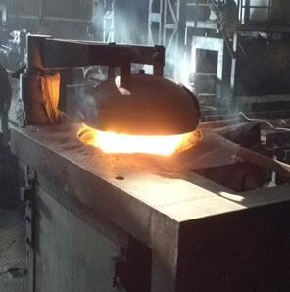
The induction furnace use crucible for melting with size varying from 300 kg to 1000 kg. The material fed to the induction furnace is of large size leading to poor capacity utilization of furnace and increased total batch time. Also, the crucible mouth is kept open during the operation resulting in high radiation losses of 5-8% of the total energy output.
The capacity utilisation of induction furnace can be improved by reducing the size of feed materials using metal cutters. This would further help in reducing the cycle time per batch. Further, retrofitting induction furnace crucible with a lid mechanism will lead to an energy saving of 3 to 5%. The extent of energy saving would depend on size of crucible and operating practises. The investment for these measures is expected to payback with one year.
Lid cover
Cost benefit analysis for furnace crucible

Particular | Unit | Value
Estimated specific energy consumption | kWh/ton | 600 - 1000
Estimated reduction in energy consumption | kWh/ton | 30 – 50
Radiation loss without lid mechanism | kWh/ton | 40
Electricity Savings with lid mechanism | kWh/ton | 20
Total annual electricity savings | kWh | 60,000
Total annual monetary savings (@100ton/month) | Rs | 3,30,000
Investment in lid mechanism | Rs | 5,00,000
Simple Payback Period | year | 1.5

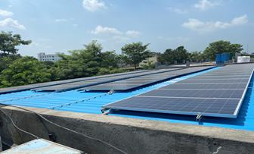
- Rooftop solar

Majority of the industries have large rooftops which can be used for installation of solar photovoltaic (SPV) systems. The industries can install solar system which can vary from 10kW to 125kW. This will help in reducing the dependency on grid supply. Industries can also avail 10% subsidy on total installation cost of roof top solar system.
Rooftop Solar

Cost benefit of a typical Rooftop Solar Installation
Particular | Unit | Value
Rooftop Area available | Sq.ft | 1,400
Installation capacity | kW | 10
Daily irradiation | kWh/m2/day | 1.0 – 1.2
Investment | Rs. | 4,00,000
Annual Savings | Rs. | 77,000
Simple Payback Period | Rs. | 5.2
*Above calculations are based on reference from MNRE website.
- Lighting
Halogen lamps (150W and 200W) and halogen bulbs (100W) are generally used by micro and small scale units. These inefficient lightings can be replaced with energy efficient LED lighting (LED tube lights of 10W and 20W) and flood lamps and high bay lamps (80W and 100 W) which would provide better illumination and energy savings. Since a large number of lamps are used in the units, the existing lighting may be replaced with EE lighting in a phased manner.

Cost benefit analysis of energy efficient lighting
Particular | Unit | Value
Power consumption with 150W halogen lamp | Watt/hr | 150
Power consumption with EE LED lights of 100W | Watt/hr | 100
Annual energy cost savings | Rs/year | 660
Investment required | Rs | 3,000
Simple payback period | Year | 4.5

Major Industrial Area Development activities

Industry associations
There are several industry associations in Jharkhand. The major industry associations and government bodies that are active in the Bokaro industrial area are briefed below.
- Jharkhand Small Industries Association (JSIA)
Jharkhand Small Industries Association is aimed to implement the State Industry Policy formulated in the year 2001 and enhancing value addition of the natural and human resources in efficient manner to generate additional employment and resources for the growth and development in the state.

- Jharkhand Industrial Area Development Authority (JIADA)
Jharkhand Industrial Area Development Authority (JIADA), Bokaro regional office is formerly known as Bokaro Industrial Area Development Authority (BIADA) is located in Balidih industrial area. It is responsible for acquisition of land, development of infrastructure facilities like road, drainage, water supply and public utilities for the development of industrial areas in the state of Jharkhand. The main objective of JIADA is to promote the industries including small, medium and large scale industries in order to ensure inclusive socio-economic growth in the state.
- SANKALP Uddyam Shakti MSME Entrepreneurs Association
The Sankalp Uddyam Shakti MSME Entrepreneurs Association is one the active associations in the industrial area. The association organises meetings and holds discusses on new initiatives and other activities like participation in exhibitions, events, technology upgradation and other development programmes.

(iv) Laghu Udyog Bharati
Laghu Udyog Bharati is one the active associations in the industrial area. The association supports all industrial units involved in manufacturing of steel related products and fabrication. It undertakes cluster level activities to accelerate manufacturing activity, achieve international competitiveness and enhance the capacity building of human resources through organizing skill development programmes.

About TERI
A dynamic and flexible not-for-profit organization with a global vision and a local focus, TERI (The Energy and Resources Institute) is deeply committed to every aspect of sustainable development. From providing environment-friendly solutions to rural energy problems to tackling issues of global climate change across many continents and advancing solutions to growing urban transport and air pollution problems, TERI’s activities range from formulating local and national level strategies to suggesting global solutions to critical energy and environmental issues.

The Industrial Energy Efficiency Division of TERI works closely with both large industries and energy intensive Micro Small and Medium Enterprises (MSMEs) to improve their energy and environmental performance.

About SSEF
Shakti Sustainable Energy Foundation was established in 2009 to facilitate India's transition to a sustainable energy future by promoting policies that encourage energy efficiency as well as the increased generation of renewable energy. The energy choices that India makes in the coming years will be of profound importance. Meaningful policy action on India's energy challenges will strengthen national security, stimulate economic and social development and keep our environment clean.

Apart from this, SSEF actively partner with industry and key industry associations on subsector specific interventions towards energy conservation and improvements in industrial energy efficiency.

